Haroutun Haroutunian

Professor Berhe

ECE 443L

17 February 2022

**Lab 2: CMOS Transistor Level Current Source**

Figure 2.1: **Case 2** DC Current Mirror with Double NMOS sizing schematic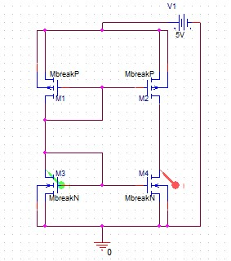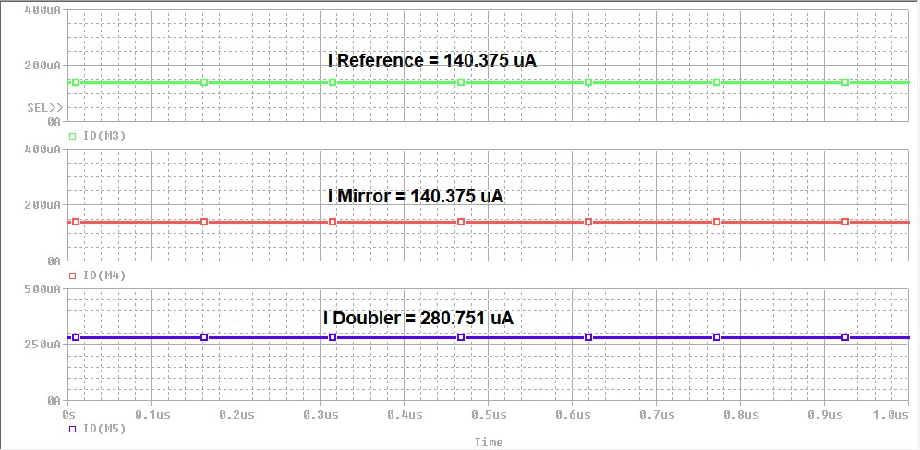

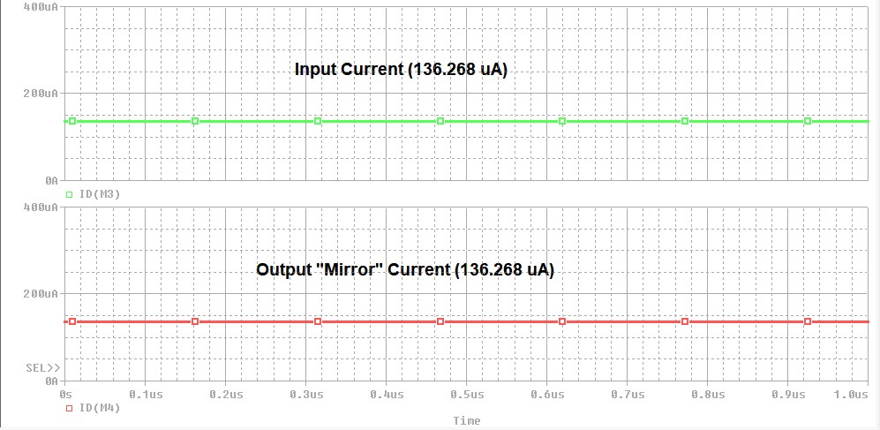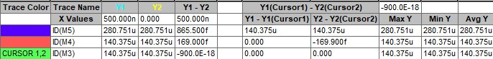

Figure 2.2: DC Current Mirror with Double NMOS sizing waveform and cursor, I/O current @ 136.268 uA

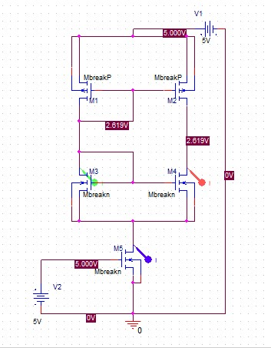

Figure 2.3: **Case 4** DC Current Mirror with Bias NMOS and 3 * (W/L) for NMOS sizing schematic

Figure 2.4: DC Current Mirror with Bias NMOS and 3 * (W/L) for NMOS sizing waveform and cursor. Reference and Mirror currents @ 140.375 uA and Doubler current @ 280.751 uA

Figure 2.5: **Case 6** AC Current Mirror with Bias NMOS and 2 * (W/L) for NMOS sizing schematic, v_in(t) = 5V square wave with f = 1 MHz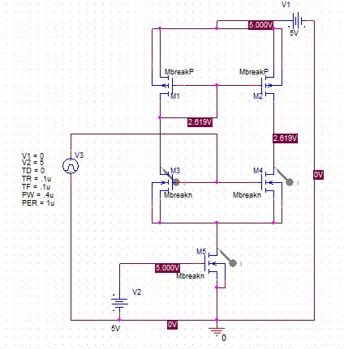

Figure 2.6: AC Current Mirror with Bias NMOS and 2 * (W/L) for NMOS sizing waveform, v_in(t) = 5V square wave with f = 1 MHz.Reference and Mirror currents @ 754.342 uA and Doubler current @ 1.5087 mA